**ASSIGNMENT-3**

**FULL STACK DEVELOPMENT(MERN STACK)**

**Name :P.Shahinaz**

**G-mail :shahnaz63050@gmail.com**

**Hallticket:209F1A0534**

**Course :Full Stack Devlopment(MERN stack).**

**College :Sri Venkateswara Institute of Technology,Anantapur.**

**STEP 1 :** Database Setup: Create a new MongoDB database called myDatabase

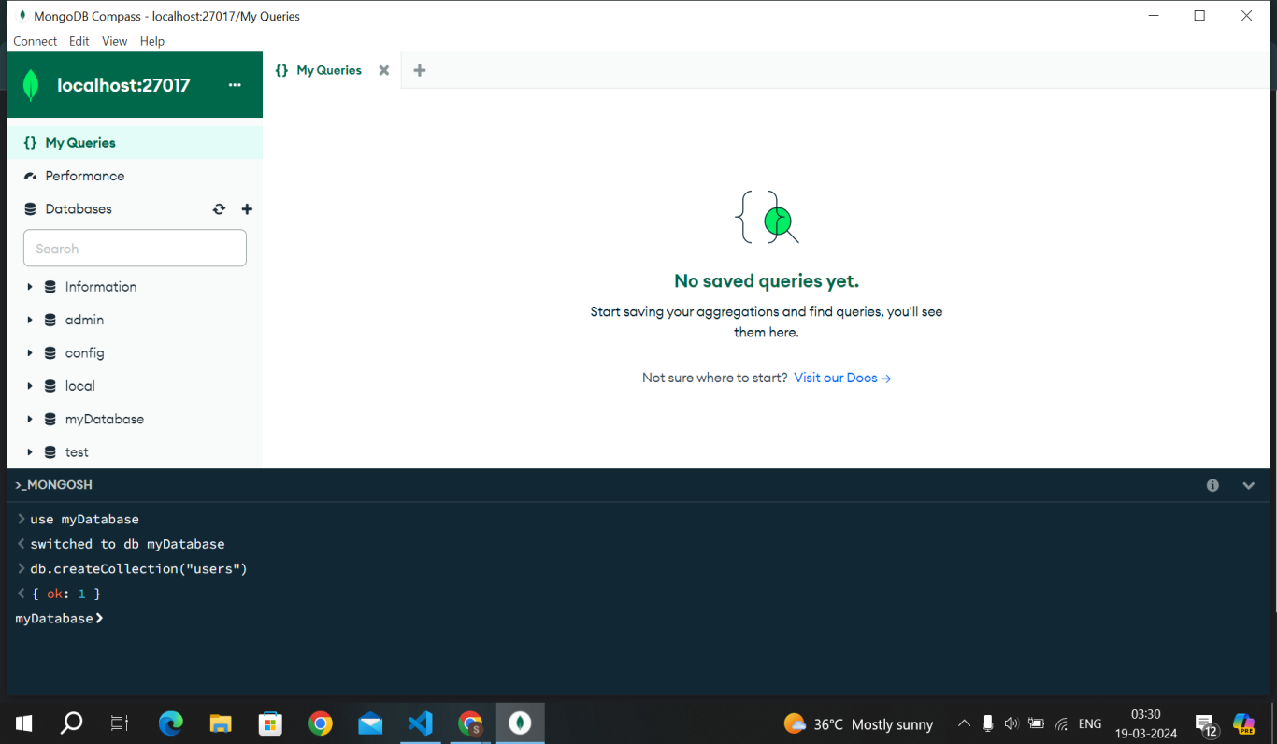

**STEP 2** : Collection Creation: Create a collection named users within the myDatabase database.

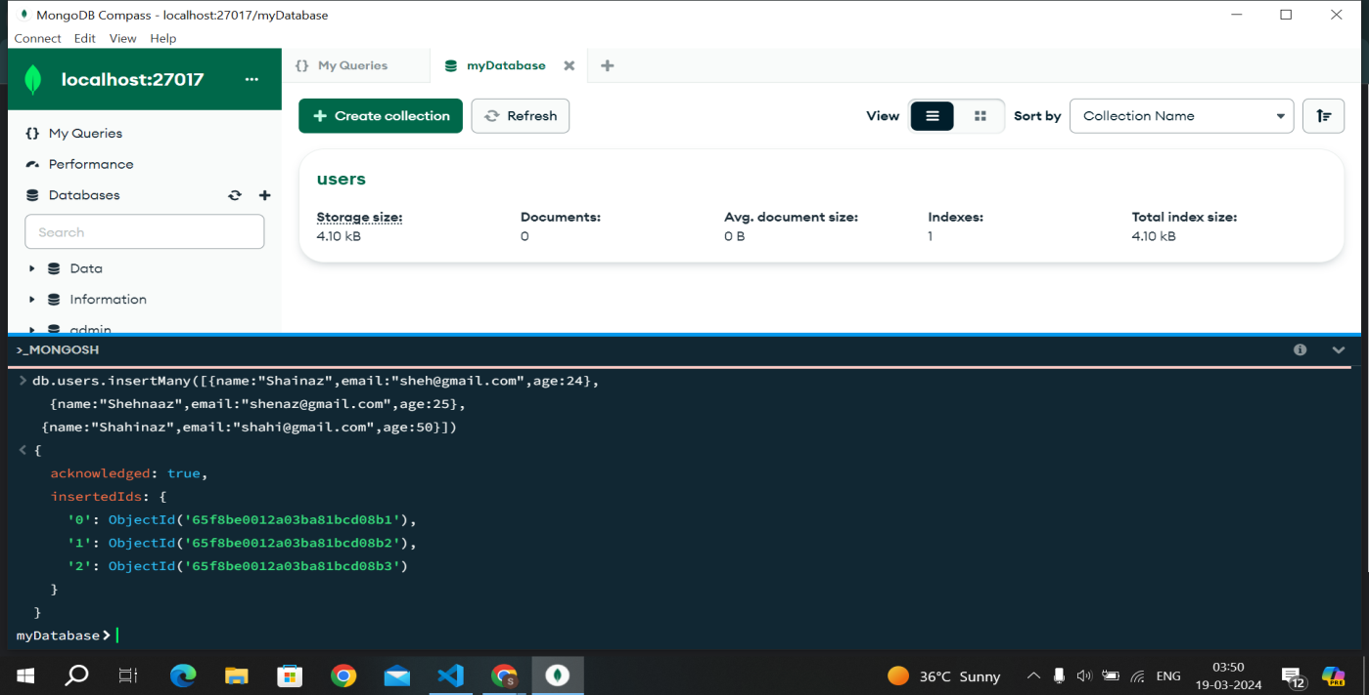

STEP 3 : Document Insertion: Insert at least three documents into the users collection, each

representing a user with fields such as name, email, and age.

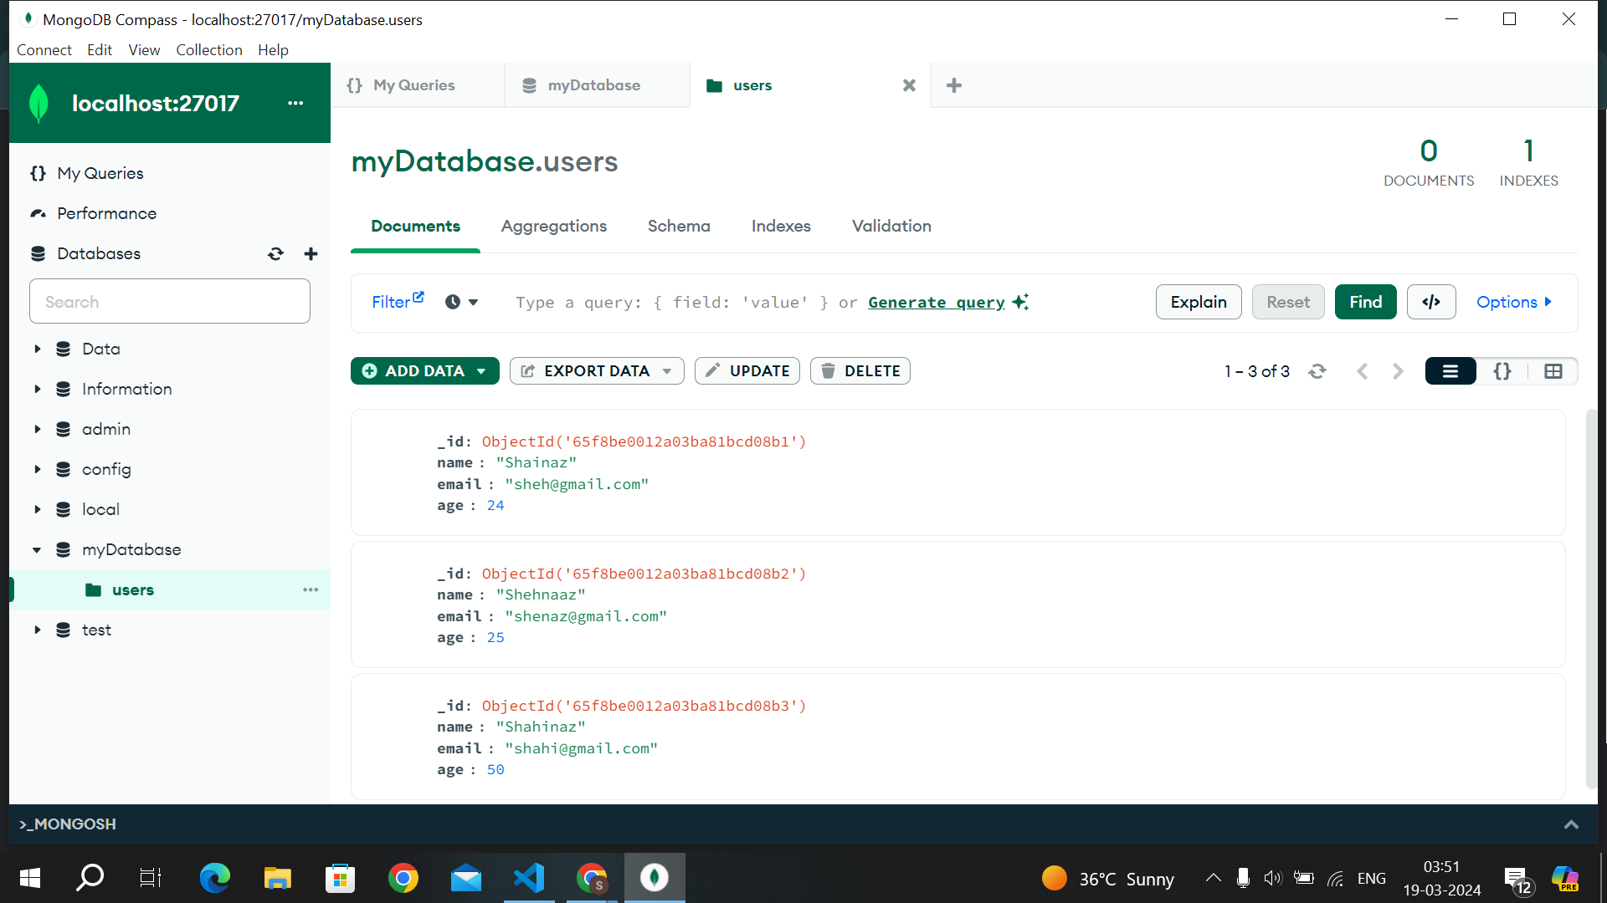

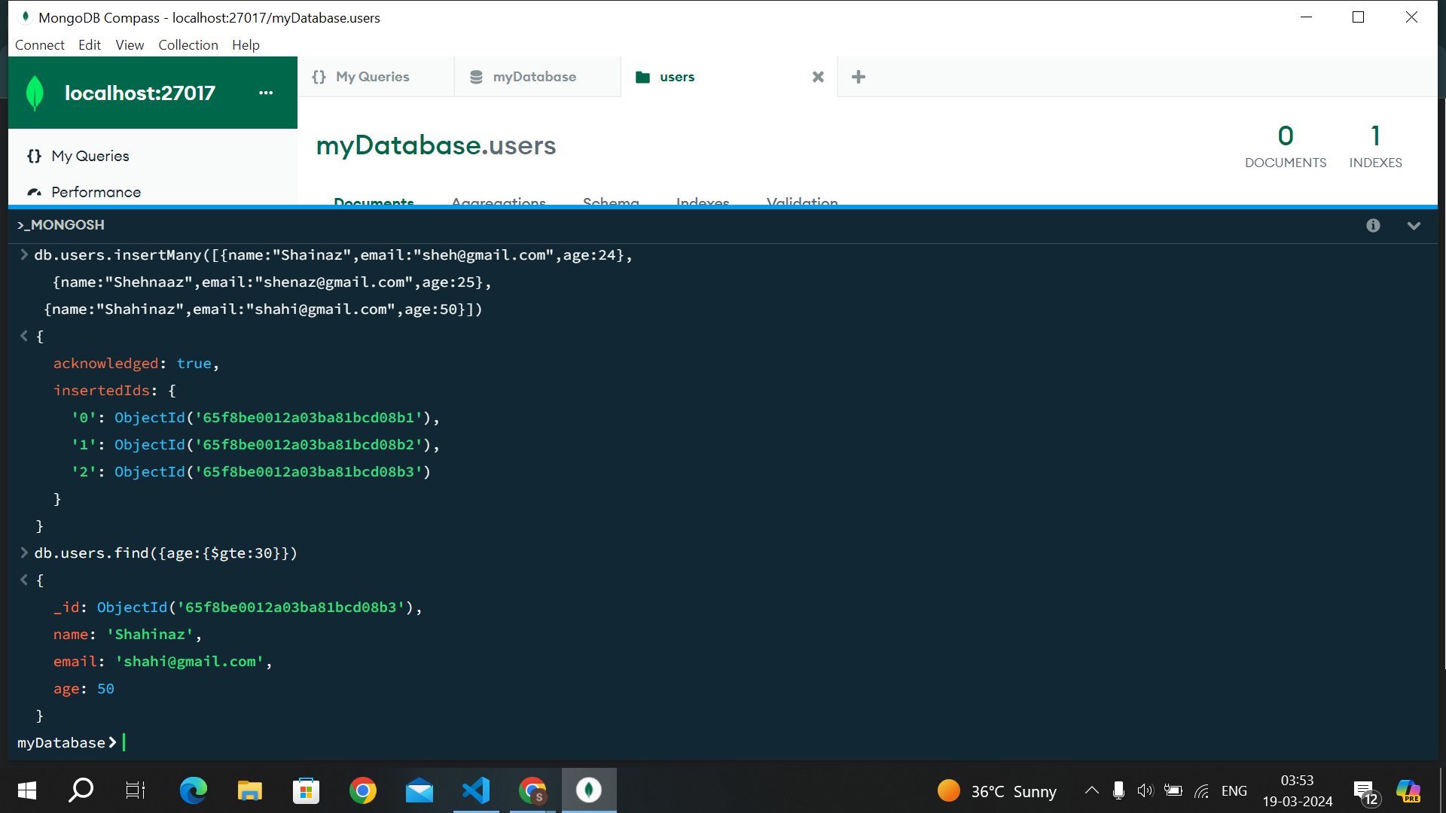

**STEP 5 :** Update Operation: Update the age of a user with a specific email address.

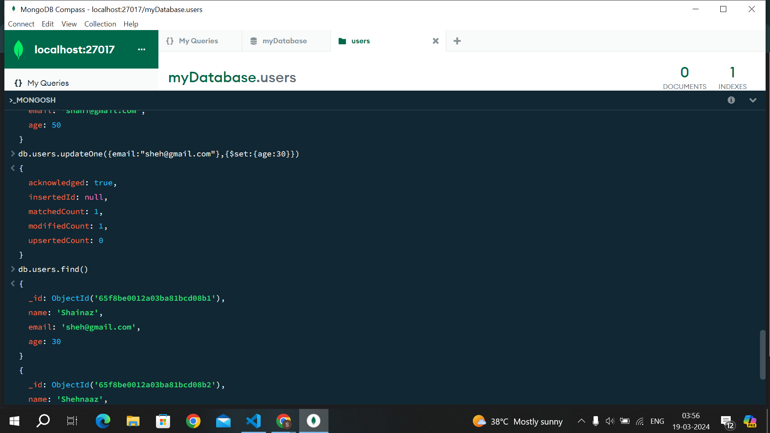

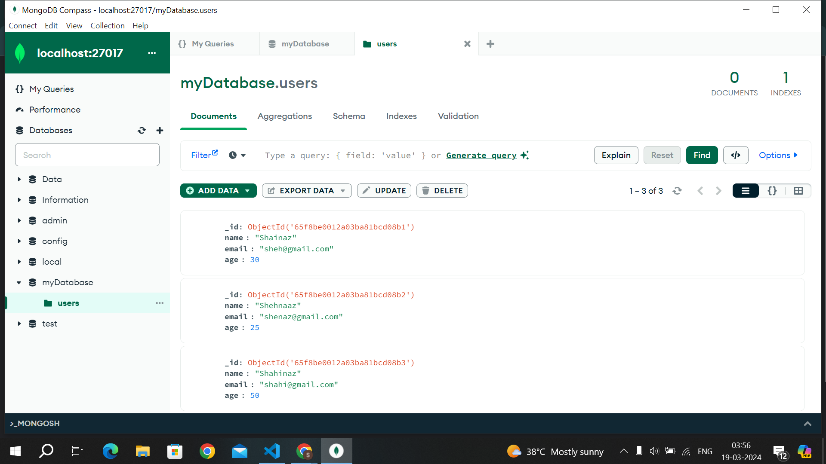

**STEP 6 :** Deletion Operation: Delete a user document based on a specific email address.

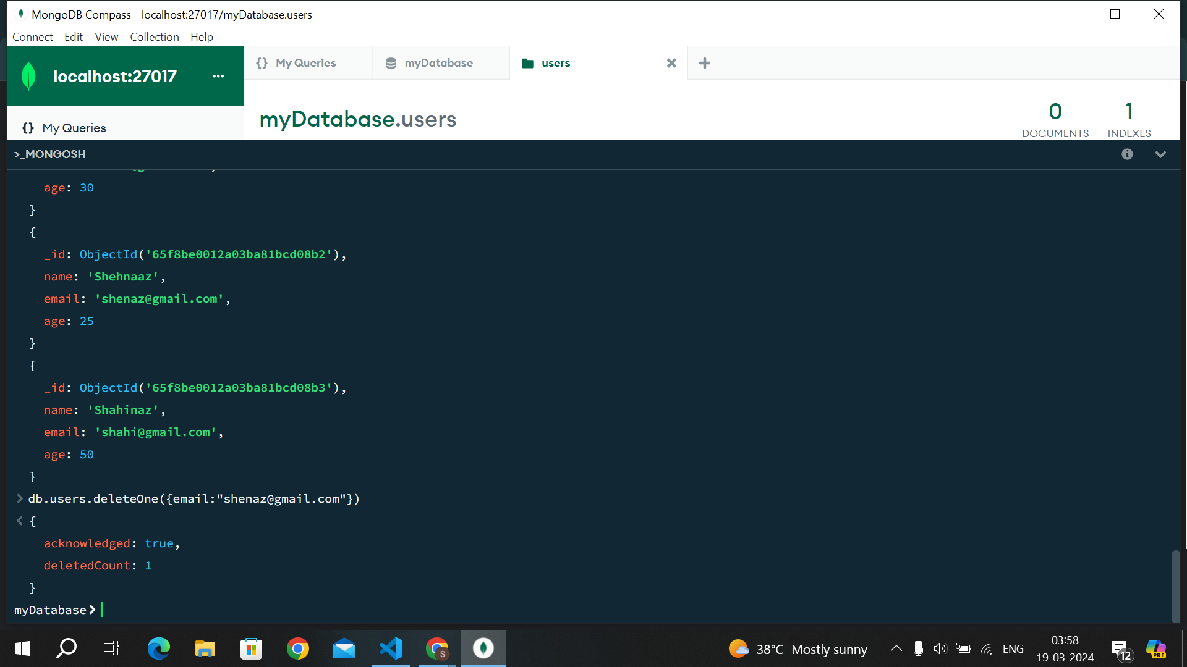

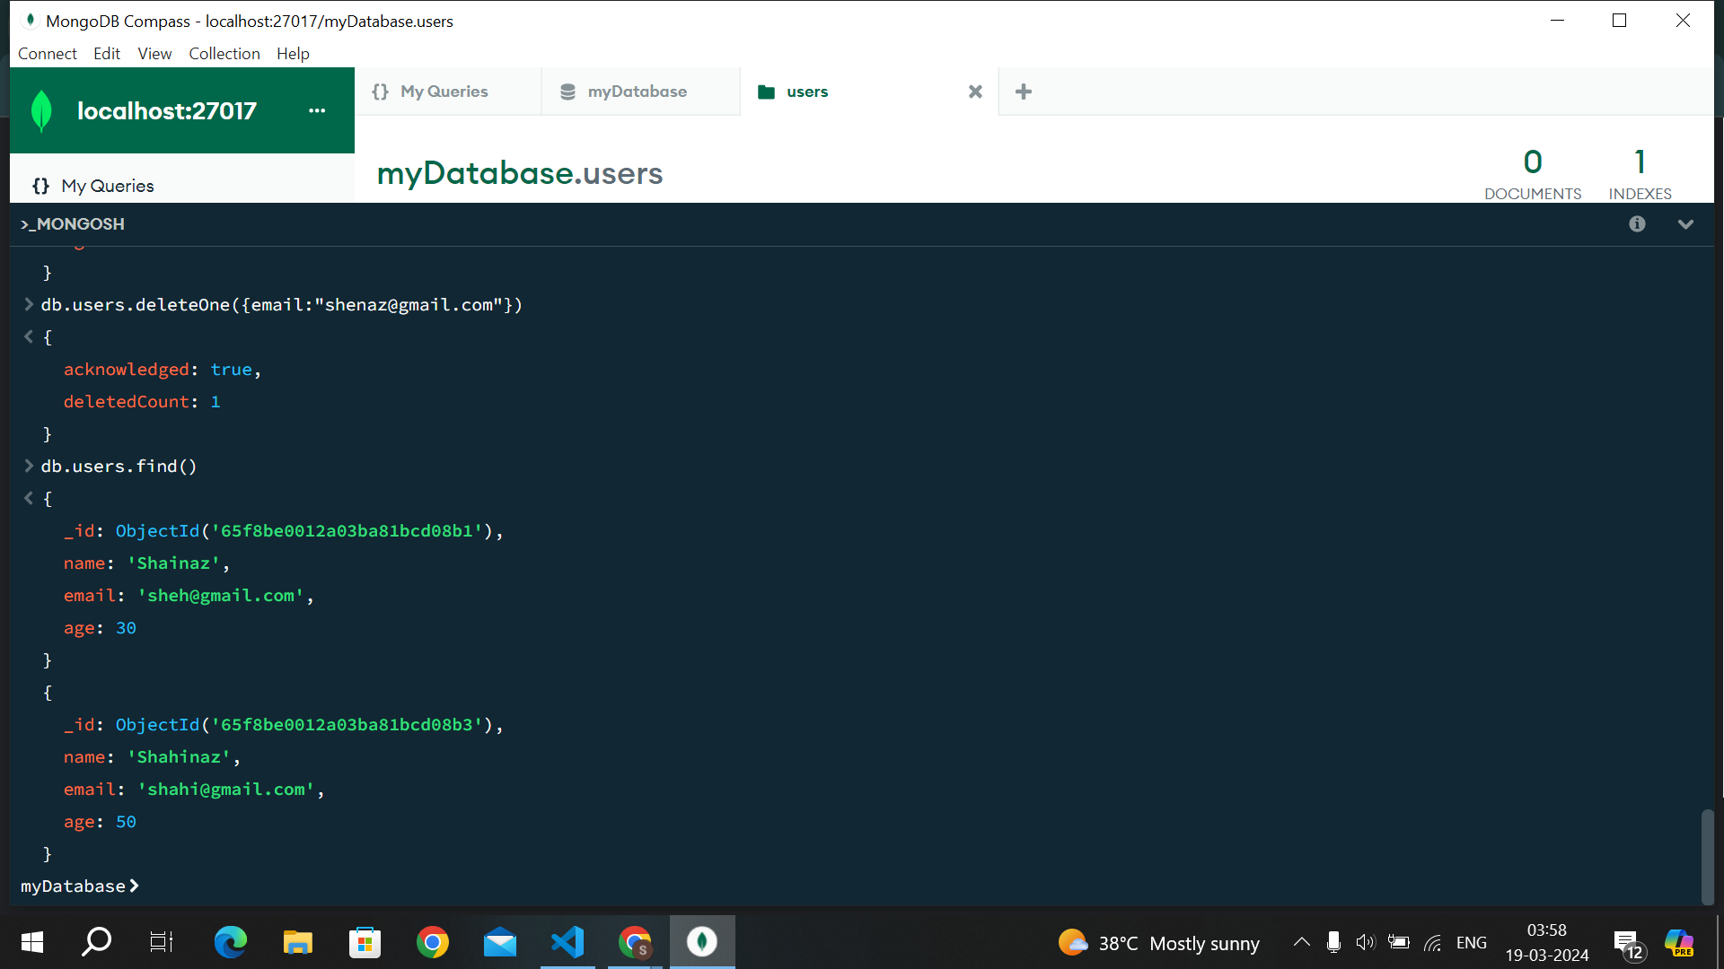

**STEP 7 :** Index Creation: Create an index on the email field of the users collection.

